Press Release 10SH13
EMO Report October 2013
SHW Werkzeugmaschinen sold 10 machines with a total value of 15 million euros
Text and photos on the Internet under www.pressearbeit.org
Largest order in the company’s history
(Aalen) At the EMO in Hanover SHW Werkzeugmaschinen received the largest single order in the history of the company. The contract was signed at the leading trade fair for metalworking and machining to supply ten travelling column machines with a total value of 15 million euros. Further orders from customers in Austria, Singapore and Bangladesh also contributed to an extremely successful exhibition as did promising talks with potential Russian and Chinese customers. However, despite a high export quota, the location of the new major customer came as a surprised.
Contact and information:
SHW Werkzeugmaschinen GmbH
Danny Basic
Alte Schmiede 1
D-73433 Aalen-Wasseralfingen
Germany
Tel. +49 7361 – 5578 813
danny.basic@shw-wm.de
www.shw-wm.de

"After a slow start to the year, our target of getting 50 machine orders this year is now within reach," SHW WM managing director Christian Hühn said with satisfaction. And the EMO has made a very significant contribution to this. At the fair, SHW Werkzeugmaschinen signed the largest single order in the company’s history: Ten machines with a total value of approximately 15 million euros will be supplied to a metalworking company. And despite SHW WM being an export-oriented company, the best news of all is the customer comes from Baden-Wuerttemberg.

Appealing to customers through added value
Four travelling column machines of the PowerSpeed 6 series are to be supplied with dual columns for synchronous machining. "Strictly speaking, there are two machines which communicate with each other,” explains Christian Hühn. By synchronous machining of large, difficult-to-handle workpieces the customer can save an enormous amount of machining time and increase both productivity and quality and all this in a single setup. Managing Director Anton Müller: "This is confirmation of our strategy to offer customers added value through excellent technology and continuous innovation." In addition to the large order, two further machines one PowerSpeed 5 and one UniSpeed 6 are to be supplied immediately.
Sold even before the fair was the latest development of the traditional company, which was also on display on the stand: their first ever gantry machine with a dynamic tool changer. The new PowerBridge is a portal milling machine equipped with a completely new, dynamic toolchanger that swaps tools during machining and a control console that travels in the work zone. The machine will be going to Austria to the cooperation partner Fill, who helped develop the machine and will also sell it. Intensive discussions were also held with three other prospective buyers interested in the new machine. Following the record year 2012 and the successful trade fair, the joint managing directors see themselves well on the way to achieving their objective of further growth in 2013.
335 words, 2.601 characters
When reprinting please send two specimen copies to SUXES
Text and photos on the Internet under www.pressearbeit.org

((SHW Werkzeugmaschinen GmbH – company information))

A young company with a long tradition
SHW Werkzeugmaschinen GmbH is one of the world’s leading manufacturers of machine tools for the machining of large components. On the machining centres with their long travel axes, components are machined for mechanical engineering, die-making and plant construction, turbine and tooling manufacture as well as for the aerospace industry, where despite their huge size, components still require a high degree of precision.
What started in 1999 as a young, innovative company in Aalen-Wasseralfingen, on closer inspection turns out to be a company with a long industrial tradition going back to 1365. Steady growth and loyalty to its Swabian roots have led to the 200 highly qualified, quality conscious employees achieving an annual turnover of 63 million euros. Presence in 45 countries ensures close proximity to customers worldwide.

SHW Werkzeugmaschinen Picture gallery, Largest order
With 2 clicks to the photos under www.pressearbeit.org
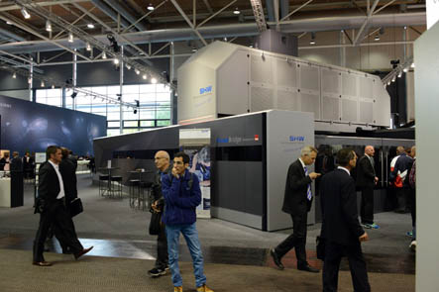
Photo No. 10-01 SH_PB-EMO.jpg.
With 13 machines sold at the EMO, SHW Werkzeugmaschinen can draw
an extremely positive balance concerning its presence at the trade fair.

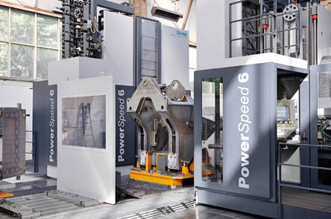
Photo No. 10-02 SH_EMO-PS6-Doppel.jpg.
With the largest order in the company’s history, SHW Werkzeugmaschinen sold 10 travelling column machines with a total value of around 15 mio. € to a customer in Baden-Württemberg.

