Press release 09ST12
The latest innovation August 2012
Swiss Tool Systems universal fine drill head Vario Head, for diameters of 3–152 mm
For text and images, visit www.pressearbeit.org
Super-Vario for fine drilling
Kontakt und Informationen:
SWISS TOOL SYSTEMS AG Christian Wagner
Wydenstrasse 28
CH-8575 Bürglen
Tel.+41 (0)71 634 85 20
Fax+41 (0)71 634 85 29
info@swisstools.org
www.swisstools.org
(Bürglen/Switzerland) Swiss Tool Systems presents a new universal boring head. The versatile Vario Head is designed for universal use, offering a boring range of 3 to 152 millimetres. An extensive array of accurately matched accessories makes the boring head ideal for different applications. The new monobloc fine drill head is compatible with standard ER collet chucks and offers rigid, centred connection. This latest product from the Swiss precision tool manufacturer can also be used for reverse drilling.
“The Vario Head provides a rigid, centred connection between the tool and the tool holder, which is easy to adjust when carrying out line boring work,” states Peter Heinemann, technical head at Swiss Tools Systems. The Swiss precision tool manufacturer’s new universal boring head covers a diameter range of 3–152 mm. The easy-to-use screw connection is quick to adjust and provides a conical face contact, providing stable connections in a similar way to HSK systems. The head can be used for a broad variety of tasks and the manufacturer confirms that it not only saves significant amounts of time and money, but also improves productivity.

A multi-purpose tool holder
The manufacturer’s tried and trusted boring bars can still be used up to diameters of 88 mm. Thanks to the intuitive ‘Push-Thru’ system, the length is freely adjustable. For example, with Vario Head, boring bars can be matched precisely to the drilling depth, for optimal machining. Also, the finish-boring head can be fitted with insert holders for diameters of up to 152 mm. With diameters of 88 mm and higher, the Swiss-made Vario Head can also be used for reverse machining. To do this, the insert holders are simply mounted in reverse. No extra adaptors are needed. The system offers a totally firm connection, especially useful for improving results and accuracy after umbalances.

Inner coolant supply right to the blade edge
The diameter can be set by using the large, easy-to-read scale. Settings can be made down to a diameter accuracy of 0.01 mm, or 0.002 mm with a nonius. The Vario Head can be used with inner coolant supply. To ensure coolant reaches the blade edge – even with large diameters – matching connectors can be fitted to channel the coolant. The Vario Head is now on sale and comes as a set complete with accessories in a handy carry-case.
390 words, 2.371 characters
Users of this text are kindly requested to send two hard copies of all published materials to SUXES.
For more text and images, please go to www.pressearbeit.org

((Firmeninfo SWISS TOOL SYSTEMS AG))

A leading name in its own right – and as an OEM
Founded in 1971, Swiss Tool Systems employs around 45 people in the manufacture of a comprehensive range of high-precision tools used in milling and lathing, with HSK, PSC and KM interfaces. It also provides modular tool systems. From its origins as a contract manufacturer of quality machine parts, the company has grown into a leading international producer of tools. Swiss Tool Systems now ranks as one of the six most important suppliers of all products used between the spindle and the blade edge. Swissflex, Swissbore, MBM, CAD and Swissmulti - its brands are known far beyond the borders of Switzerland. Especially in top-of-the-range applications involving the HSK interfaces A 63 and A 100 (under DIN standard 69893), Swiss Tools offers a broad selection of stationary and rotating tools. It also plays an active role as an OEM for leading companies. In the last financial year, Swiss Tool Systems AG generated sales of around 10.5 million Swiss francs (approx. 8.75 million euros).

Image gallery: SWISSTOOLS Vario Head fine drilling head
Download images in just 2 clicks at www.pressearbeit.org
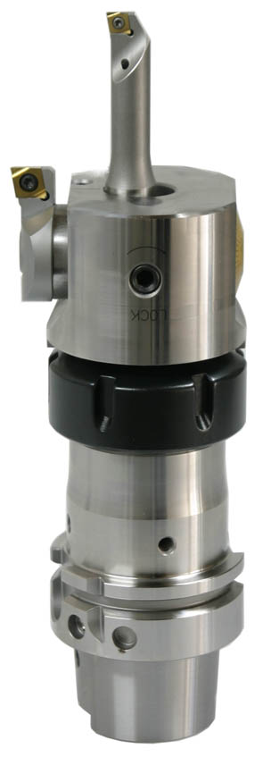  Ref. 09-01 ST_ER-Variohead.jpg  New: The Vario Head universal boring head from Swiss Tool Systems. Shown here with ER interface, compatible with ER collet chuck. | 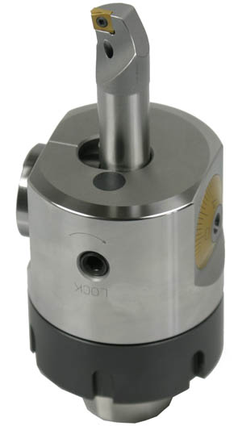  Ref. 09-02 ST_Variohead.jpg  Boring ranges of 3–152 mm: The new Swiss Tool Systems Vario Head is versatile and can be used in many areas.
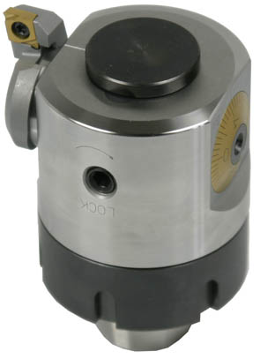  Ref. 09-03 ST_Variohead2.jpg  For diameters of 88 mm and higher, the Swiss-made Vario Head can also be used for reverse machining. | 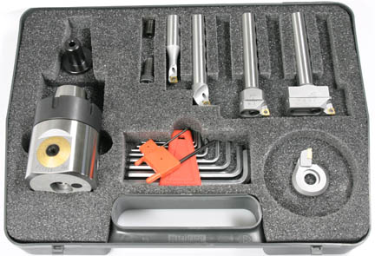  Ref. 09-04 ST_VarioheadKoffer.jpg  Now available: The new Swiss Tool Systems Vario Head comes as a set complete with accessories in a handy carry-case.

