Wachendorff: Hall 7, Stand 151

Press release WA1507: robust draw-wire system SZG140
Images and text have been authorised for publication by the press department (print and online). Please send us a specimen copy upon publication. Many thanks in advance for your efforts.

The robust draw-wire system SZG140: precise length measurement up to 10200 mm

Do you need to record positions, speeds and distances travelled, for example, with crane booms, hydraulic cylinders or screw conveyors as efficiently and securely as possible? Wachendorff Automation provides operators and construction engineers with tuned draw-wire systems that guarantee quick and flexible mounting on your machine and offers robust performance with a high degree of protection to IP65. Precise measurement is ensured by optimised fairlead and constant wire tension across the entire measuring distance. In association with the incremental encoders in the WDGI series or the absolute encoders in the WDGA series, ideal resolution, great accuracy and optimal interfaces can be achieved. The new SCG140 system is designed for lengths of up to 10200 mm.
The wire exit can be individually positioned using the fixing bracket. In combination with the incremental and absolute encoders from Wachendorff Automation, the draw-wire system’s robust performance means that the system can also be used in challenging operating conditions such as in harbour cranes or in transport systems in refrigerated warehouses.

Further information can be found at: http://www.wachendorff-automation.com/draw-wire_system

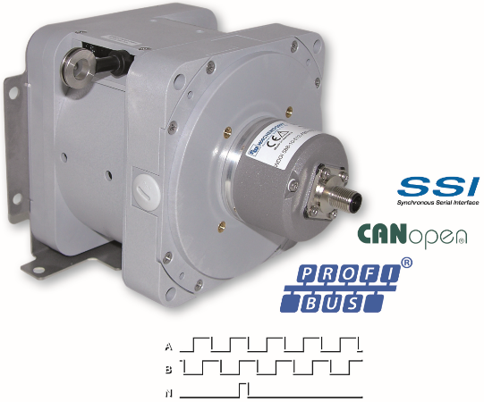
Images (Wachendorff):

PI_WA1507_Seilzugsystem_SZG140_19112015.jpg

