|  |  |  |
| --- | --- | --- |
| Press contact:  **CONEC Elektronische Bauelemente GmbH**  Katja Schade  Phone: 02941/765-350  Fax: 02941/765-65 | Ostenfeldmark 16  D-59557 Lippstadt  www.conec.com | Conec Logo |

Press Release 01.02/2018

### Title: CONEC ISOBUS overmoulded – now available with three different cable versions for extended use of larger wire cross sections

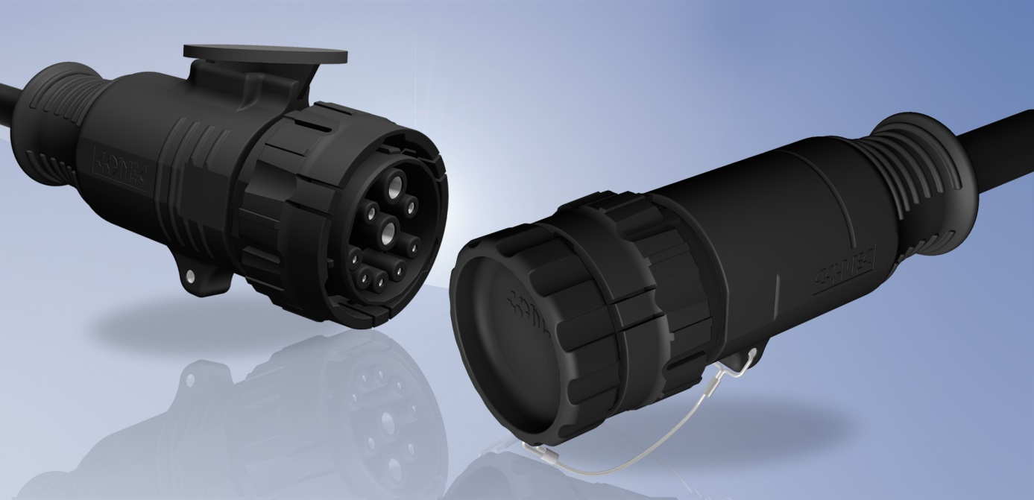



With increasing demands on the efficiency in agriculture, precision farming is becoming more and more important. Precision farming indicates for the targeted management of utilized agricultural land, e.g. the individual application of fertilizers and plant protection products depending on the position of the utilized land.

To ensure the necessary communication between tractor, equipment and agricultural management software, the non-proprietary ISOBUS is used. ISOBUS is specified in standard ISO 11783-2 and describes the BUS including the connectors used with it.

Up to now the ISOBUS-program is expanded with contacts and contact carriers which offers an extended use of larger wire cross sections. There are now three different cable versions available, which are specially designed for agricultural applications. The cable variants differ in the cross-section of the ground and power stranded wires with 6 mm², 10 mm² and 16 mm².

The overmoulded ISOBUS-series is available as connector with female contacts. The contact carrier has the 9-pin contact layout specified by the standard ISO 11783-2. Due to the overmould, continuous IP67 protection of the housing up to the hybrid cable is ensured.

The ISOBUS connector is plugged into the so-called IBBC socket on the tractor. In the IBBC socket, the bayonet coupling is disabled and the connector is locked by means of a spring bracket. The spring bracket serves to secure the inserted ISOBUS connector. At the same time, it fulfills the "breakaway" function, which guarantees defined opening of the bracket in case of sudden pulling force on the cable.

In unmated condition the connector is protected by a cap against dust and humidity. This cap fulfills the protection grade IP67. By default the cap is secured to the connector with a stainless steel lanyard.

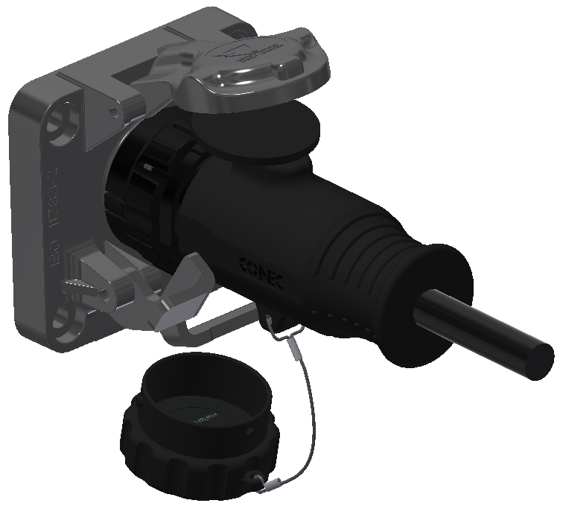

Landingplate

Protection cap ISOBUS IBBC socket

Protection cap with lanyard

Spring bracket

When not plugged in, the IBBC socket is protected from moisture and dirt by a protective cap with integrated seal. The ISOBUS connector is equipped with a landing plate to protect the sealing of the protective cap even when plugged in. The standard version of the landing plate is round, optionally there is also a landing plate with a flattened outer surface on both sides. Upon request, the connector can also be supplied complete without landing plate.

Productdetails:

**Fields of application:**

• Agricultural machines

• Construction machines

• Technical emergency vehicles

• Process control

**Benefits:**  
• Robust and ergonomic design

• Version with or without landing plate

• Three cable types available

• Standard with captive dust cap

• Due to the overmould, continuous IP67 protection of the housing

up to the hybrid cable is ensured

• Use in harsh environments

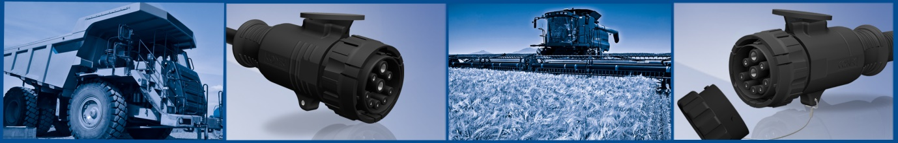

**Technical data:**

|  |  |  |  |
| --- | --- | --- | --- |
|  | Hybrid cable type 600P | Hybrid cable type1000P | Hybrid cable type1600P |
| Current rating | 6 mm² : 25 A / 40 °C  2.5 mm² : 15 A / 40 °C  0.5 mm² : 5 A / 40 °C | 10 mm² : 35 A / 40 °C  2.5 mm² : 15 A / 40 °C  0.5 mm² : 5 A / 40 °C | 16 mm² : 60 A / 40 °C  2.5 mm² : 15 A / 40 °C  0.5 mm² : 5 A / 40 °C |
| Protection class | IP67 | | |
| Terminal cross section | 2x 6 mm² + 2x 2.5 mm²  + 4x 0.5 mm² | 2x 10 mm² + 2x 2.5 mm² +  4x 0.5 mm² | 2x 16 mm² + 2x 2.5 mm² +  4x 0.5 mm² |
| Mating cycles | > 100 | | |
| Ambient temperature - connector | -40° C ... +85 °C | | |
| Ambient temperature - cable | Fixed: -40 ° C - +80 °C  Variable: -20 °C - +80 °C | Fixed: -40 °C - +80 °C  Variable: -20 °C - +80 °C | Fixed: -40 °C - +80 °C  Variable: -20° C - +80 °C |